Practice Numbers

https://www.facebook.com/events/565360187190280/565397730519859

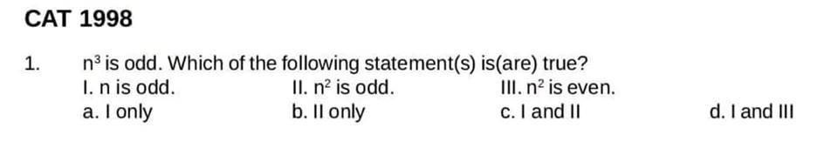

 If n^3 is odd, then n should also be odd. Hence, n^2should also be odd.   
  
And n^2 will again be odd and not even. So only I and II are true.

CAT 1998

2. A certain number, when divided by 899, leaves a remainder 63. Find the remainder when the samenumber is divided by 29

Since 899 is divisible by 29, so you can directly dividethe remainder of 63 by 29, so63 mod 29 = 5 as aremainder

3. A is the set of positive integers such that when divided by 2, 3, 4, 5, 6 leaves the remainders 1, 2, 3,4, 5 respectively. How many integers between 0 and 100 belong to set A?

a. 0  
b. 1  
c. 2  
d. None of these

As all remainders are 1 less than the numbers so  
  
Number must be Lcm (2 to 6)k-1 form   
= 60k-1   
  
Only one such in 0 to 100 range is 59.

4. How many five-digit numbers can be formed using the digits 2, 3, 8, 7, 5 exactly once such that the number is divisible by 125?

To be divisible by 125, last 3 digits must br divisible.   
  
So from given digits last 3 digits can be 375 and 875   
  
For each last 3 digits. First two digits can be assigned in 2 ways each.   
  
So 2 + 2 = 4

CAT 1998

5. What is the digit in the unit’s place of 2^51?

Unit digit has cyclicity of 4.   
  
So 2^51 = 2^(48+3)=2^(4k+3)= 2^3 =8

CAT 1998

6. A number is formed by writing first 54 natural numbers in front of each other as 12345678910111213...

Find the remainder when this number is divided by 8.

last 3 digits mod 8 = 354 mod 8 = 2

Divisibility of 8 is last 3 digits   
  
Last few digits are 52 53 54   
  
Last 3 digits 354  
  
Ans 354 mod 8 = 2

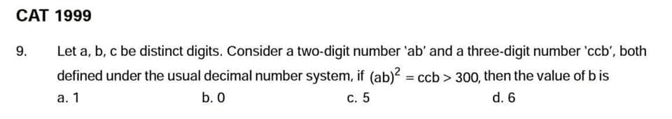

by hit and trial

21^2 = 441 so b = 1.

8. The remainder when 7^84 is divided by 342 is

7^84 = 343^28 mod 342 = 1

We know 7^3 = 343   
  
So 7^84 = (7^3)^28  
  
= 343^28 mod 342 = 1^28= 1

CAT 1999

9. If n^2 = 12345678987654321, what is n?

Pattern   
  
11²=1 21  
  
111²= 12 321  
  
No. Of 1's follows consecutive digits..  
  
So 12345678 987654321= 111111111²

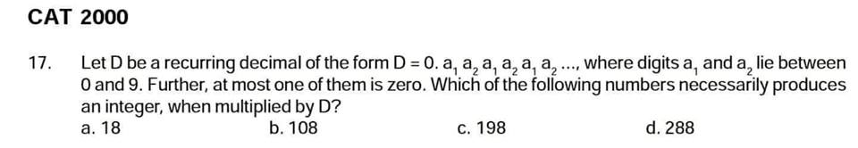

0.ababababab....can be written as ab/99 which multiplied by 198 gives 2*ab, thus an integer.

Recurring means repeating.   
  
So 0.ab = ab/99   
  
So (ab/99)*D = integer   
  
when D is a multiple of 99. So only option C

CAT 2000

The integers 34041 and 32506, when divided by a three-digit integer n, leave the same remainder.What is the value of n?

Any number= divisor* k + remainder  
  
So N1 = a*k + r   
N2 = b*c + r   
  
N1 - N2 = ak - bc   
  
That 3 digit must be divisible by ak - bc ( as remainder has been cancelled)   
  
Number must be factor of difference of the two numbers .   
  
34041-32506=1535  
  
Factor of 1535 which is 3 digit is 1535/5=307  
  
[#iQuanta](https://www.facebook.com/hashtag/iquanta?hc_location=ufi)

CAT 2001

[Sagar Vj](https://www.facebook.com/sagar.vj.5?fref=mentions) had to do a multiplication. Instead of taking 35 as one of the multipliers, he took 53. As aresult, the product went up by 540. What is the new product?

53x - 35x = 540

x = 30

so new product = 30 * 53 = 1590

Let the number be x.  
  
Increase in product = 53x – 35x = 18x   
  
⇒18x = 540 ⇒  
  
x = 30  
  
Hence new product = 53 × 30 = 1590

1. The product of 3 consecutive odd numbers is 531117. Then sum of these numbers is ??

( 30 seconds)

The three numbers must be around cube root of the number. ~80   
  
So try with 79*81*83   
  
It satisfies so 79+81+83 = 243

 N = 2^a*3^b   
  
b= even  
a-1 = even ( 0,2,4....)   
As after dividing by 2 , both should be even . ( to give perfect square)   
  
And for cube: a must be 3k form, and b = (3k+1)   
  
So combining: a => 3, b = 4   
  
So N = 2^3*3^4   
  
Ans : 4*5= 20

N must be of the form 2^a*3^b  
  
Ye samjhe ? Coz after dividing by 2 or 3 its still integer

Now as given in ques  
  
2^a * 3^b divided by 2 = square   
  
Means a - 1 = even  
And also b = even   
  
Ye samjhe ?

Now on dividing 2^a *3^b /3 we get cube   
  
=> 2^a * 3^(b-1) is a cube   
  
So a = 3k form , b-1 is 3k too  
  
So we have a -1= 2k , a= 3k   
=> a = 3 smallest   
  
Now b = 2k , b -1= 3k   
=> b = 4 smallest   
  
N = 2^3* 3^4 smallest   
  
Factors : 4x5 = 20

What will be the remainder if 7777....37 times divided by 19 ??

E(19)= 18   
  
So divisible till 18 digits   
  
37 mod 18 = 1   
  
Left with unit digit   
  
So 7 mod 19 = 7   
  
[#iQuanta](https://www.facebook.com/hashtag/iquanta?hc_location=ufi)

3. Last non zero digit of 30! Is ?

30 = 5*6+0   
  
So ans : 2^6*6! : 4*2= 8

4) How many numbers less than 100 have exactly 4 odd factors but no even factors?

4 factors means a^3 or a*b form.   
  
Now for odd factors, a or b can take only odd primes. So  
  
a^3, : 3^3 ,   
  
a*b : 3*(5 to 31) : 9  
5*(7 to 19) : 5  
7*( 11, 13) : 2  
  
Total 17

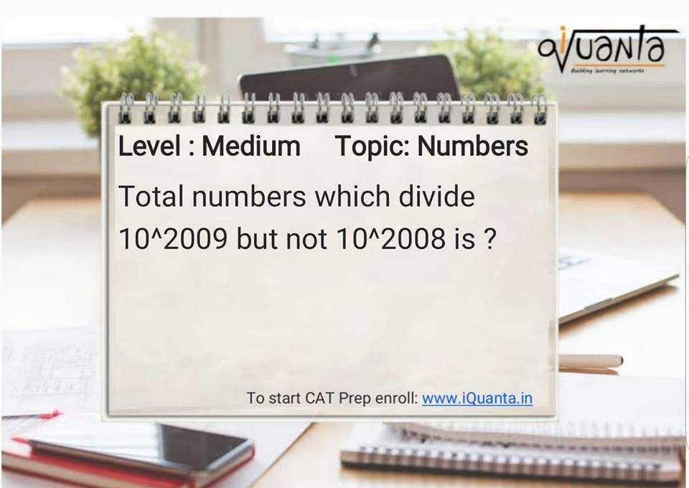

10^2009= 2^2009*5^2009   
Number of factors = (2010)^2  
  
10^2008= 2^2008*5^2008  
Number of factors= (2009)^2  
  
Therefore ans= factors of 10^2009 - factors of 10^2008  
  
2010^2- 2009^2= 4019  
  
[#iQuanta](https://www.facebook.com/hashtag/iquanta?hc_location=ufi)   
  
Samjhe mitron ?

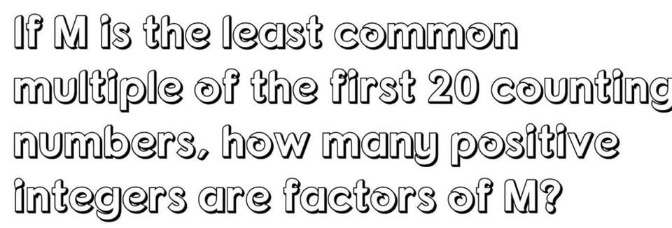

960  
  
2^4 x 3^2 x 5 x 7 x 11 x 13 x 17 x 19

Smallest number divisible by first 10 natural numbers is ?

2^3 * 3^2 * 5 * 7 = 2520

Lcm of (1 to 10)  
  
=> 2^3 * 3^2 * 5 * 7 = 2520

For how many of the first 300 natural numbers is the total number of factors even?

all perfect squares have odd number of factors.

so we need count of numbers which are not perfect squares.

Only perfect squares have odd number of factors   
  
Ans : Total no - perfect square   
  
300-17 = 283  
  
( as 17^2 is largest possible square < 300)

For how many of the first 300 even natural numbers is the total number of factors even?

300*2 = 600

perfect square less than 600 = 24

no of even square roots is 12.

so ans = 300 - 12 = 288

300 - even squares till 600  
  
300 - 12 = 288

q. how many values x can take below 30 for which 50!-x! will have 6 zeroes?

25! has 6 zeroes.

so 25!,26!,27!,28!,29! are 5 below 30 for which there are 6 zeroes.

ans : 5